**CONTRACT – USER SERVICE**

1) Fetch all users (GET):

**This API Will get existing place details from Server**

**Complete URL :** <http://localhost:8080/api/v1/users>

**Base URL**: <http://localhost:8080/api/v1/>

**Resource**: /users

**Path Parameters**: N/A

**Http request**: GET

**Authorization:** Need to choose “Basic Auth” and give either of the following credentials

a) username / password : genUser / password (with USER role)

b) username / password : admin / password (with ADMIN role)

**Sample Response for the request**

|  |
| --- |
| [{"id":1,"title":"Mr","firstName":"Leanne","lastName":"Bret","gender":"male","address":{"street":"Kulas Light","city":"Gwenborough","state":"dfdsfs","postcode":"92998-3874"}},{"id":2,"title":"mr","firstName":"test","lastName":"tsetlast","gender":"male","address":{"street":"12345 holling rd","city":"Sydney","state":"nsw","postcode":"2000"}},{"id":3,"title":"mrs","firstName":"Malini","lastName":"Vaikuntam","gender":"female","address":{"street":"12345 holling rd","city":"Sydney","state":"nsw","postcode":"2000"}},{"id":4,"title":"mr","firstName":"Geroge","lastName":"Graham","gender":"male","address":{"street":"12345 polling rd","city":"Sydney","state":"nsw","postcode":"2020"}},{"id":5,"title":"mrs","firstName":"Serena","lastName":"Joseph","gender":"female","address":{"street":"12345 rolling rd","city":"Sydney","state":"nsw","postcode":"2020"}},{"id":6,"title":"mrs","firstName":"Juliet","lastName":"Davis","gender":"female","address":{"street":"1245 tolling rd","city":"Sydney","state":"nsw","postcode":"2020"}}] |

**Reference Screenshot for request**

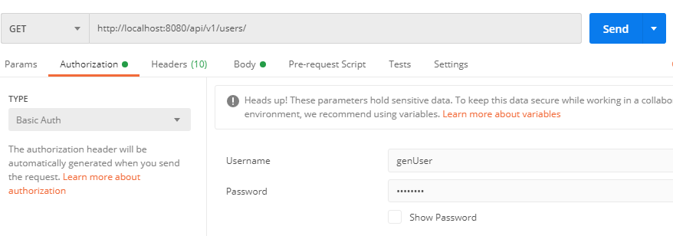

**Reference Screenshot for response**

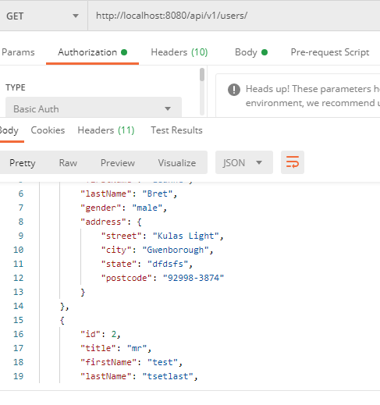

2) Fetch one user (GET):

**This API Will get existing place details from Server**

**Complete URL :** <http://localhost:8080/api/v1/users/4>

**Base URL**: http://localhost:8080/api/v1

**Resource**: /users

**Path Parameters**: Any id (Eg. 4)

**Http request**: GET

**Authorization:** Need to choose “Basic Auth” and give either of the following credentials

a) username / password : genUser / password (with USER role)

b) username / password : admin / password (with ADMIN role)

**Sample Response for the request**

|  |
| --- |
| {      "id": 4,      "title": "mr",      "firstName": "Geroge",      "lastName": "Graham",      "gender": "male",      "address": {          "street": "12345 polling rd",          "city": "Sydney",          "state": "nsw",          "postcode": "2020"      }  } |

**Reference Screenshot for the request**

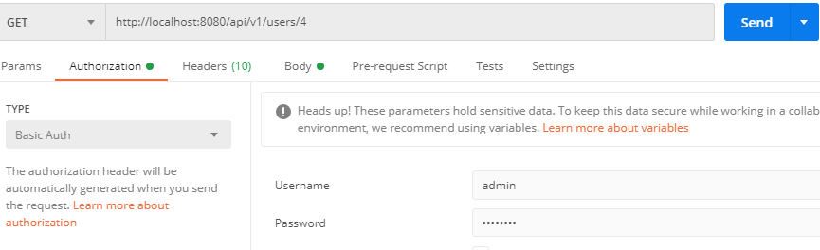

**Reference Screenshot for the response**

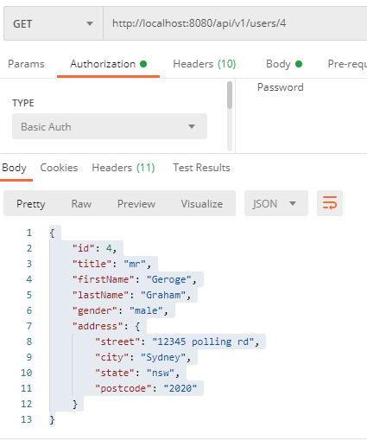

3. Update User (PUT):

**This API will update an existing user record with new values**

**Complete URL :**<http://localhost:8080/api/v1/users/>

**Base URL**: http://localhost:8080/api/v1

**Resource**: /users

**Path Parameters**: N/A

**Http Request**: PUT

**Sample Body** :

{

    "id": 2,

    "title": "mrs",

    "firstName": "Deepak",

    "lastName": "genUser",

    "gender": "female",

    "address": {

                  "street": "12345 holling rd",

                  "city": "Melbourne",

                  "state": "VIC",

                  "postcode": "3000"

     }

  }

**Authorization:** Need to choose “Basic Auth” and give either of the following credentials

username / password : admin / password (with ADMIN role)

**NOTE**:: User with USER role won’t have permissions

**Sample Response for the request**

|  |
| --- |
|  |

**Reference Screenshot for the request**

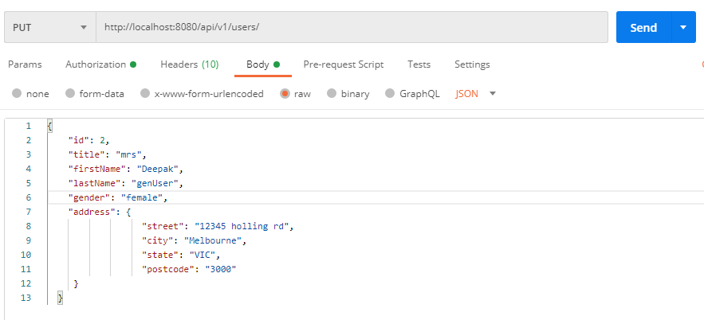

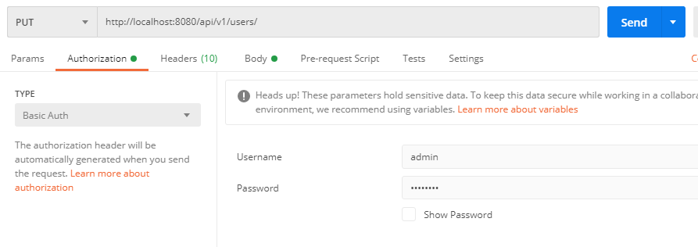

**Reference Screenshot for the response**

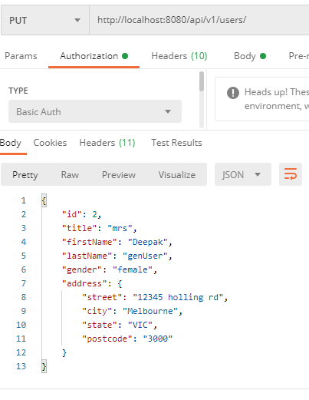

**Response with “genUser” having USER role**

